A project proposal by  
 Md. Yeasir Arafat  
16-02-04-093  
Rakib Hossian Rifat  
16-02-04-099  
Argha Shipan Sarker  
16-02-04-110

***Blood Bank Management***

SECTION: B2

COURSE NO: CSE 2100

COURSE TITLE: Software Development II

Submitted To  
Golam Rahman Tushar Sir

**Introduction:** The purpose of the Blood Bank is to simplify and automate the  
process of searching for blood donor’s in case of emergency. With the help of this  
Blood Bank one person can easily search for his desired blood group donor in his  
desired area and can also see if that person can give him blood or not. We have made our Blood Bank Management System for an organization who would search the blood donors for the needy person. When a person cannot make direct communication, they can seek help from the organization and find blood donors which can save the life of a dying person.

**Features:** In our Blood Bank Management System we have tried to add different features which will help the organization to search Blood donors very quickly in a short time. Little description of every features is given below.

* Login Page:

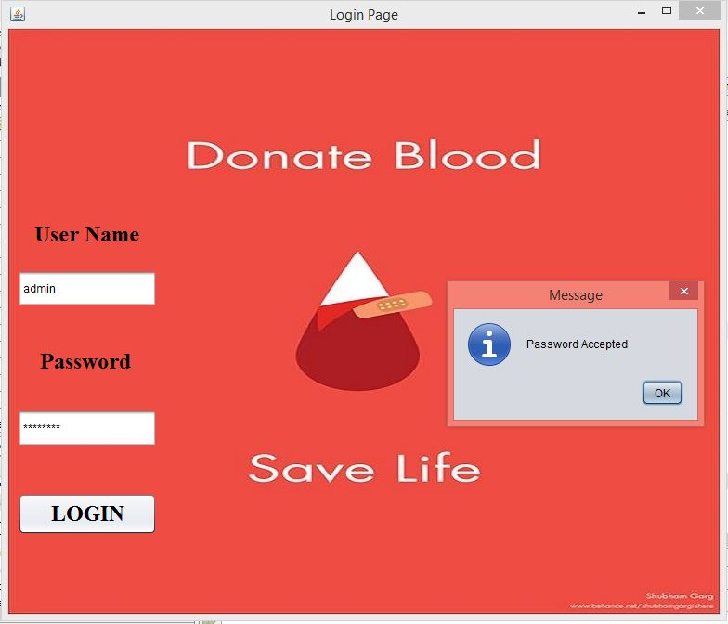

From this frame the software starts and help to connect to other frame which are needed. In this frame, there is User Name and Password for the person who is going to operate the management system. Only the authorized persons can access the management system.

* Option page:

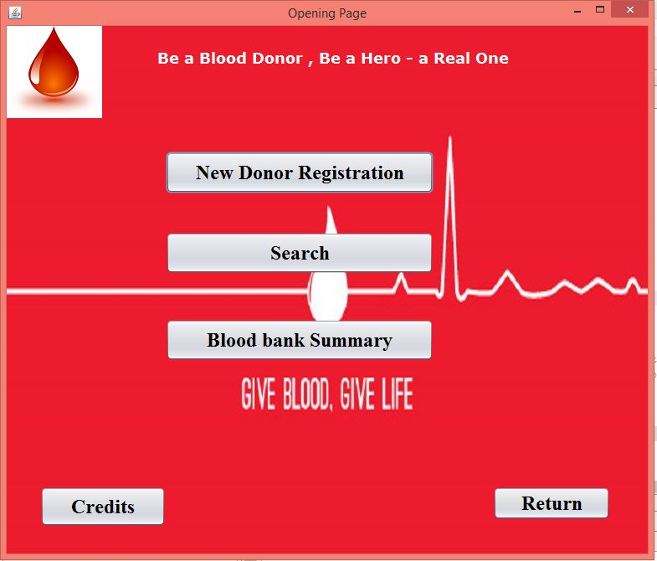

In this frame there are 5 different buttons doing five different tasks.

New Donor Registration: For collecting the information of a person, who wants to become a blood donor.

Search: For searching desired blood group in different areas.

Blood Bank Summary: For showing all the information of all blood donors.

Credit: For going to the credit frame.

Return: For returning to the Login page.

* Registration Page:

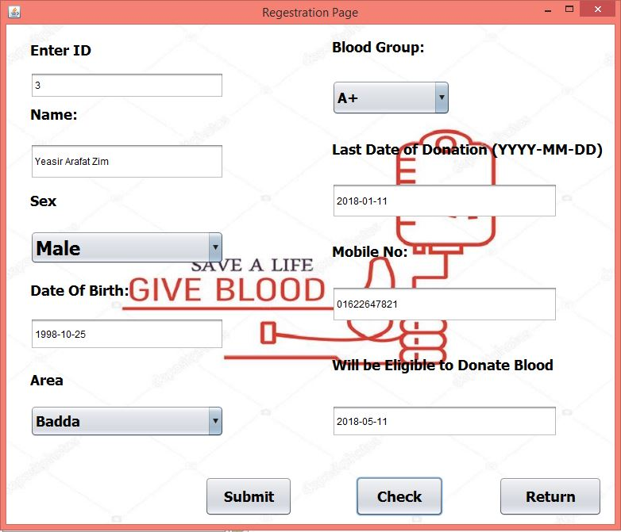

This frame is used for collecting all the information of the blood donor and for saving it in the database.

* Search Page:

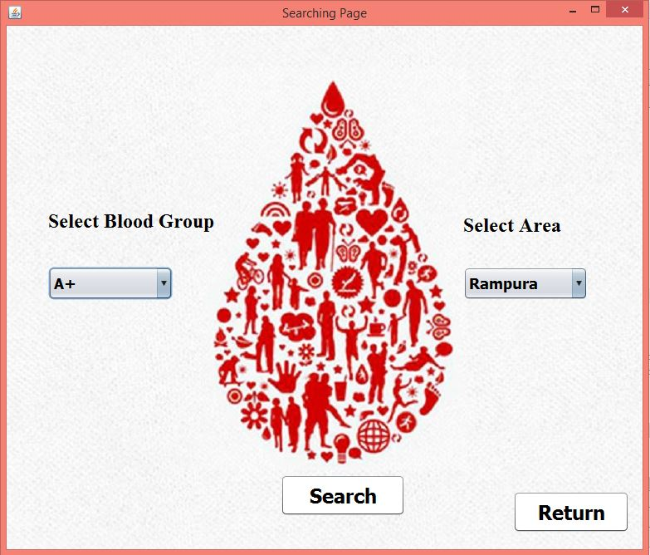

In our management system blood donor can be searched by Blood Group & Area wise. And in the search result our system will show only that donors those who are active on that particular day.

* Updating Page:

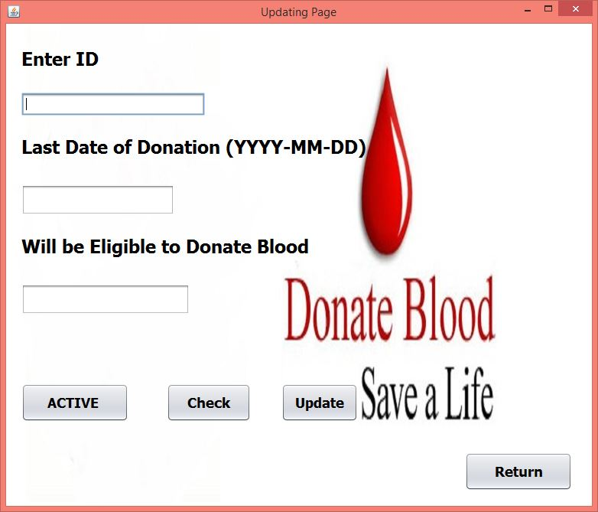

After giving blood to a person, a donors last date of donation will be updated in this frame. As a result our system can calculate in which upcoming date that donor will again be activated.

* Blood Bank Summery:

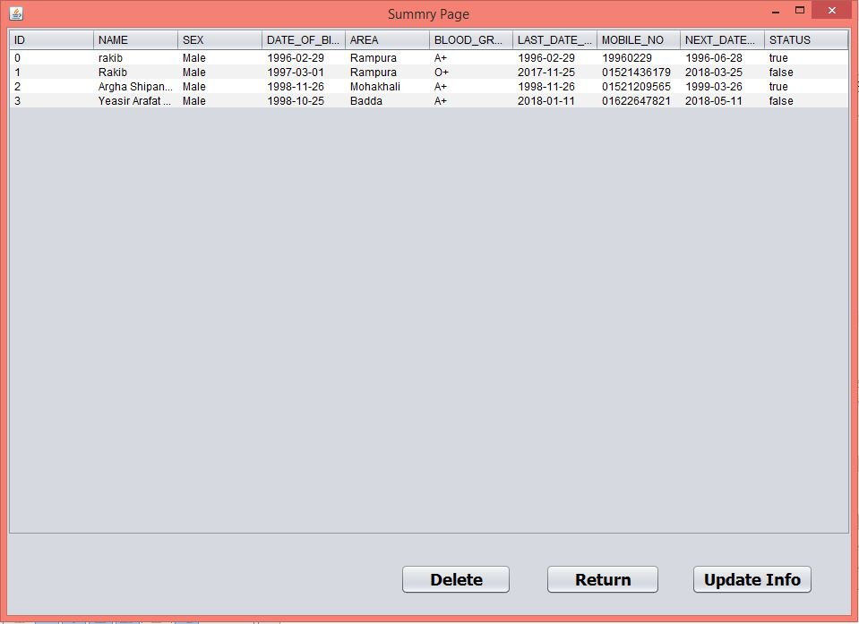

This frame contains all the information of the blood donors.

**Conclusion:** In our project we have tried to add all the features that will help a person to search blood donors in an efficient way. From our management system the organization will also be able to keep a track of active and inactive blood donors. We hope that our management system will help the needy persons by providing them blood in crucial time.